Abstract:

Our program will be an advanced math calculator with a wide variety of math problems that can be solved with just a few inputs from the user. The calculator does all the work by taking the users input based on what type of math and function they selected at the start-up menu. These types include algebra, trigonometry, geometry and calculus. After the user makes their selection, the program will then prompt the user to enter the necessary inputs to solve their problem.

Team Members:

Kennedy Burks – GitHub username: kennedyburks

Nathan Mixon – GitHub username: Natemixon7

Garrett Smith – GitHub username: GHS730

Christian Hinkle – GitHub username: include-iostream

GitHub Repository:

<https://github.com/include-iostream/CSCI325GroupProject>

Program Description:

Our program will be able to solve basic algebraic problems like squaring numbers and find the square root of numbers. It will also be able to do more advanced math like finding the distance between two points on a graph and solving sine and cosine functions.

Description of UI:

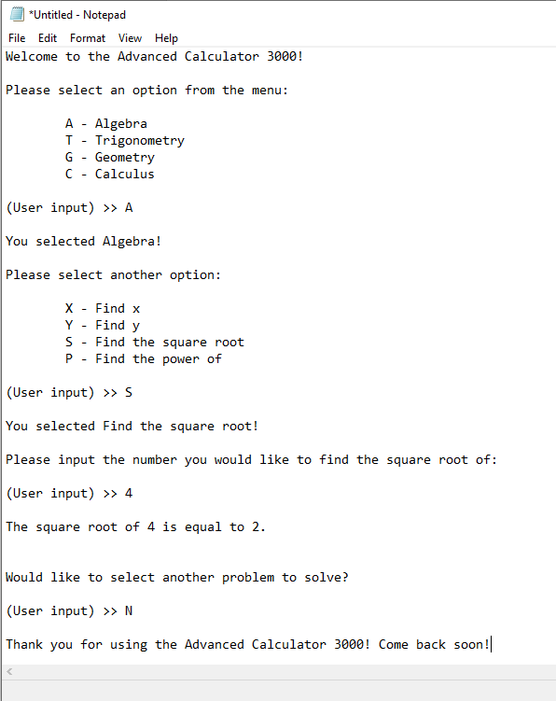Our program will be using a command line user interface.

Labor Division:

The labor will be broken up into the different section of math. We have four group members so each member will cover a branch of math. If one member finishes their branch early, then they will transition to help another member who is stuck or in need of help.

UML Use Case Diagram:

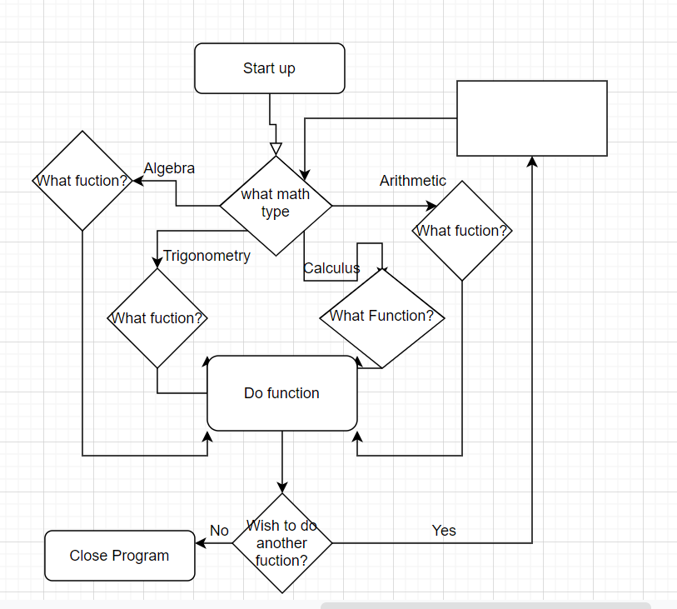

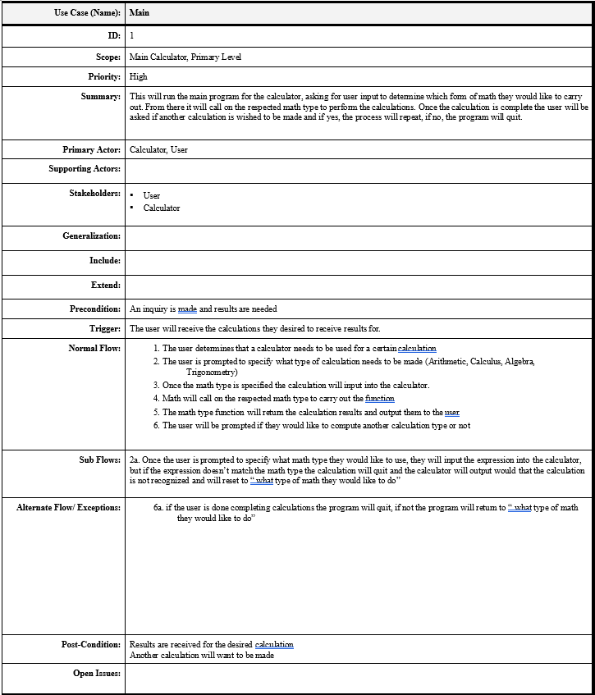Use Case Description:

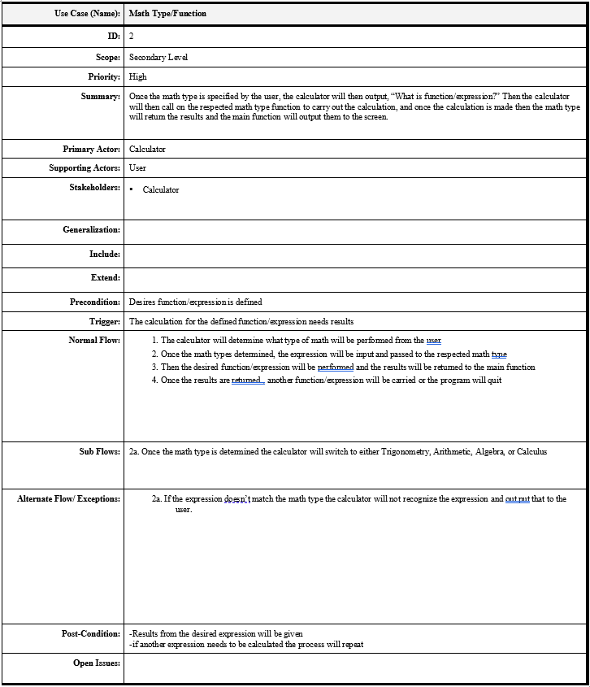

Method of Communication:

Our team will be using Discord as our primary form of communication.

Link can be found here: <https://discord.gg/JTy52G2NrF>

Technologies:

Our team will be using:

* Java
* Java JVM runtime
* GitHub
* NetBeans IDE
* Git

General Overview of Division of Labor:

Kennedy – ArithmeticCalculator Class and Main Function

* This class will calculate a wide variety of basic to medium level arithmetic problems like powers, square roots, and multiplication.

Nate – TrigonometricCalculator Class and Main Function

* This class will calculate a wide variety of basic to complex Trigonometric problems like trigonometric ratios, problems related to the unit circle, and exact values of sin.

Garrett – GeometryCalculator Class and Main Function

* This class will calculate a wide variety of basic to complex Geometric problems like perimeter of shapes, area of shapes, height of a triangle, and volume of a cylinder.

Christian – AlgebraCalculator Class and Main Function

* This class will calculate a wide variety of basic to complex Algebraic problems like quadratic formula, solving for x, and factoring.

UML Case Diagram for Classes:

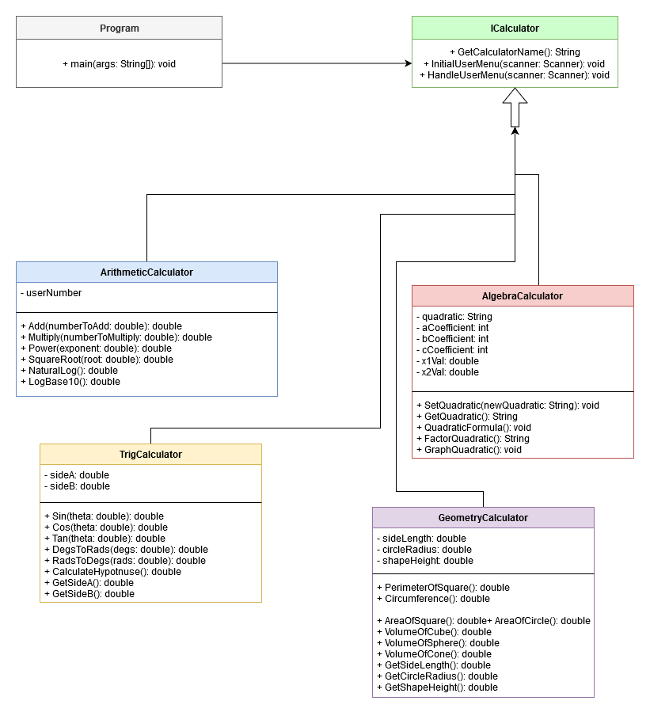

Who Did What:

Kennedy – Updated GitHub Usernames.

Nate – Descriptions of the classes and Requirements phase deliverable.

Garrett – General overview of division of labor.

Christian – UML Case Diagram’s and setup Technologies.